### Guide to Adding and Editing Content on the Project Page

#### Access the Admin Dashboard

1. Navigate to: [ADM Dashboard](https://infinitaproductions.com/admin/wp-admin/)
2. Log in with your username and password.

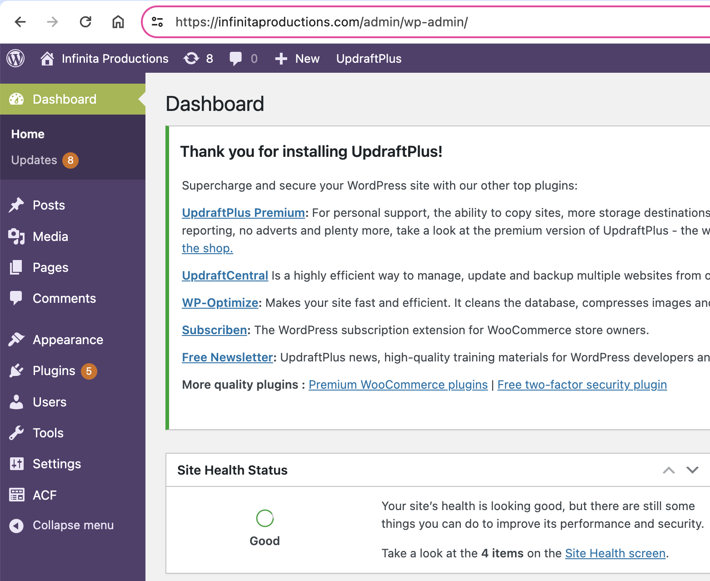

#### Project Management

Each project is presented as a post on WordPress. To edit existing content or add new projects, follow these instructions:

##### Editing Existing Content

1. Navigate to Posts.
2. Choose the project you want to edit.
3. Edit the fields following the same instructions as for creating a new project.

##### Adding a New Project

1. Go to Posts.

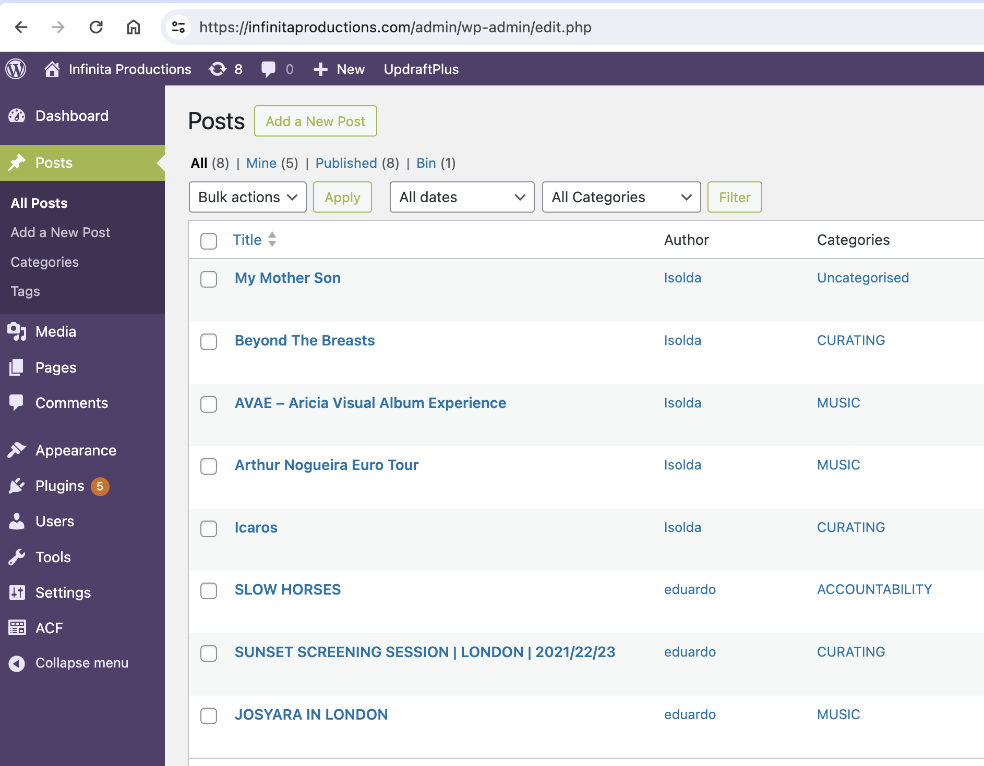

1. Go to Add a New Post.



1. This screen will open:

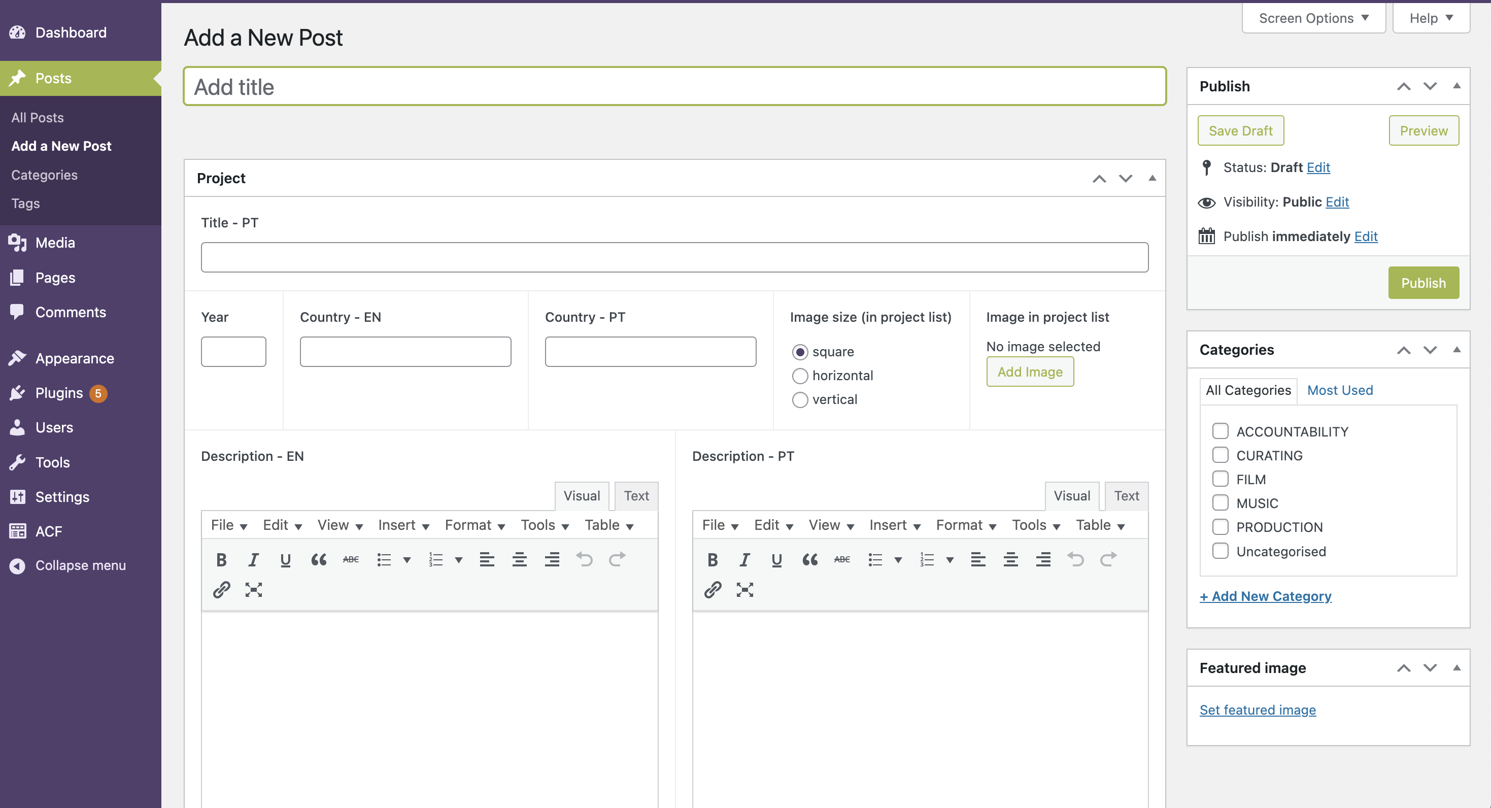

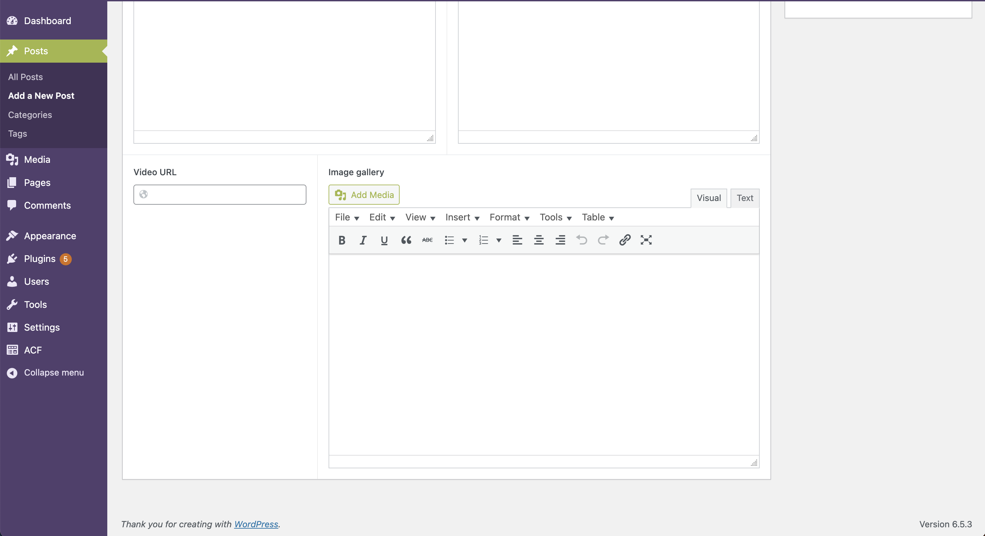

**Important Note:**  
A new project will only be displayed on the website if you add an image for the Grid. The field for this image is labeled **"Image in project list"** in the new Post.

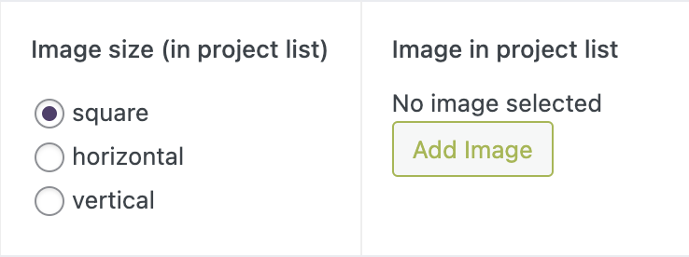

##### Filling in Project Content

a. **English Title**



b. **Portuguese Title**

  
  
c. **Year**



d. **Country in English**



e. **Country in Portuguese**



f. **Select Image Orientation**  
Select if you want a square, horizontal, or vertical image in the projects' images grid.



g. **Adding an Image to the Grid in Projects Page**

* Go to **Image Project List**. Click **Add Image**.



* Set the grid's image. Select an image from the media library if the image is already there, or...

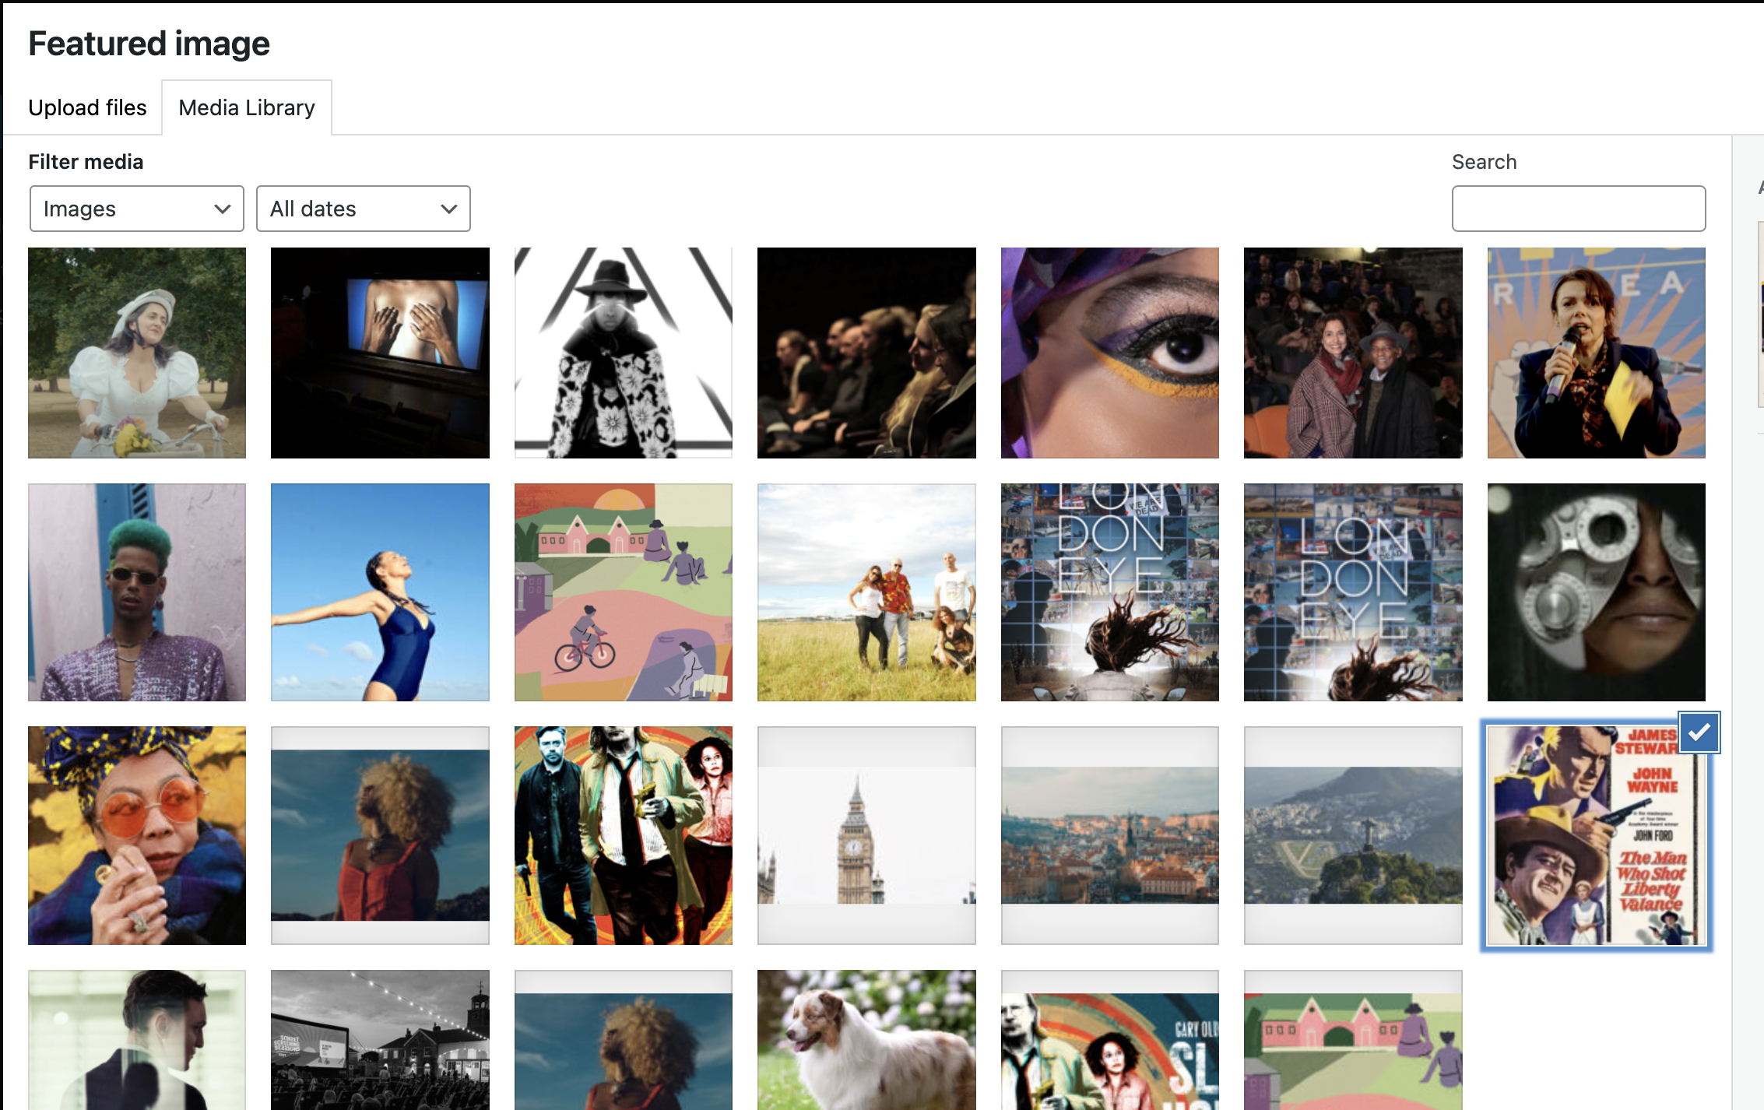

* Go to **Upload Files**.
* Drop or select an image (maximum 256 MB).
* Set featured image.

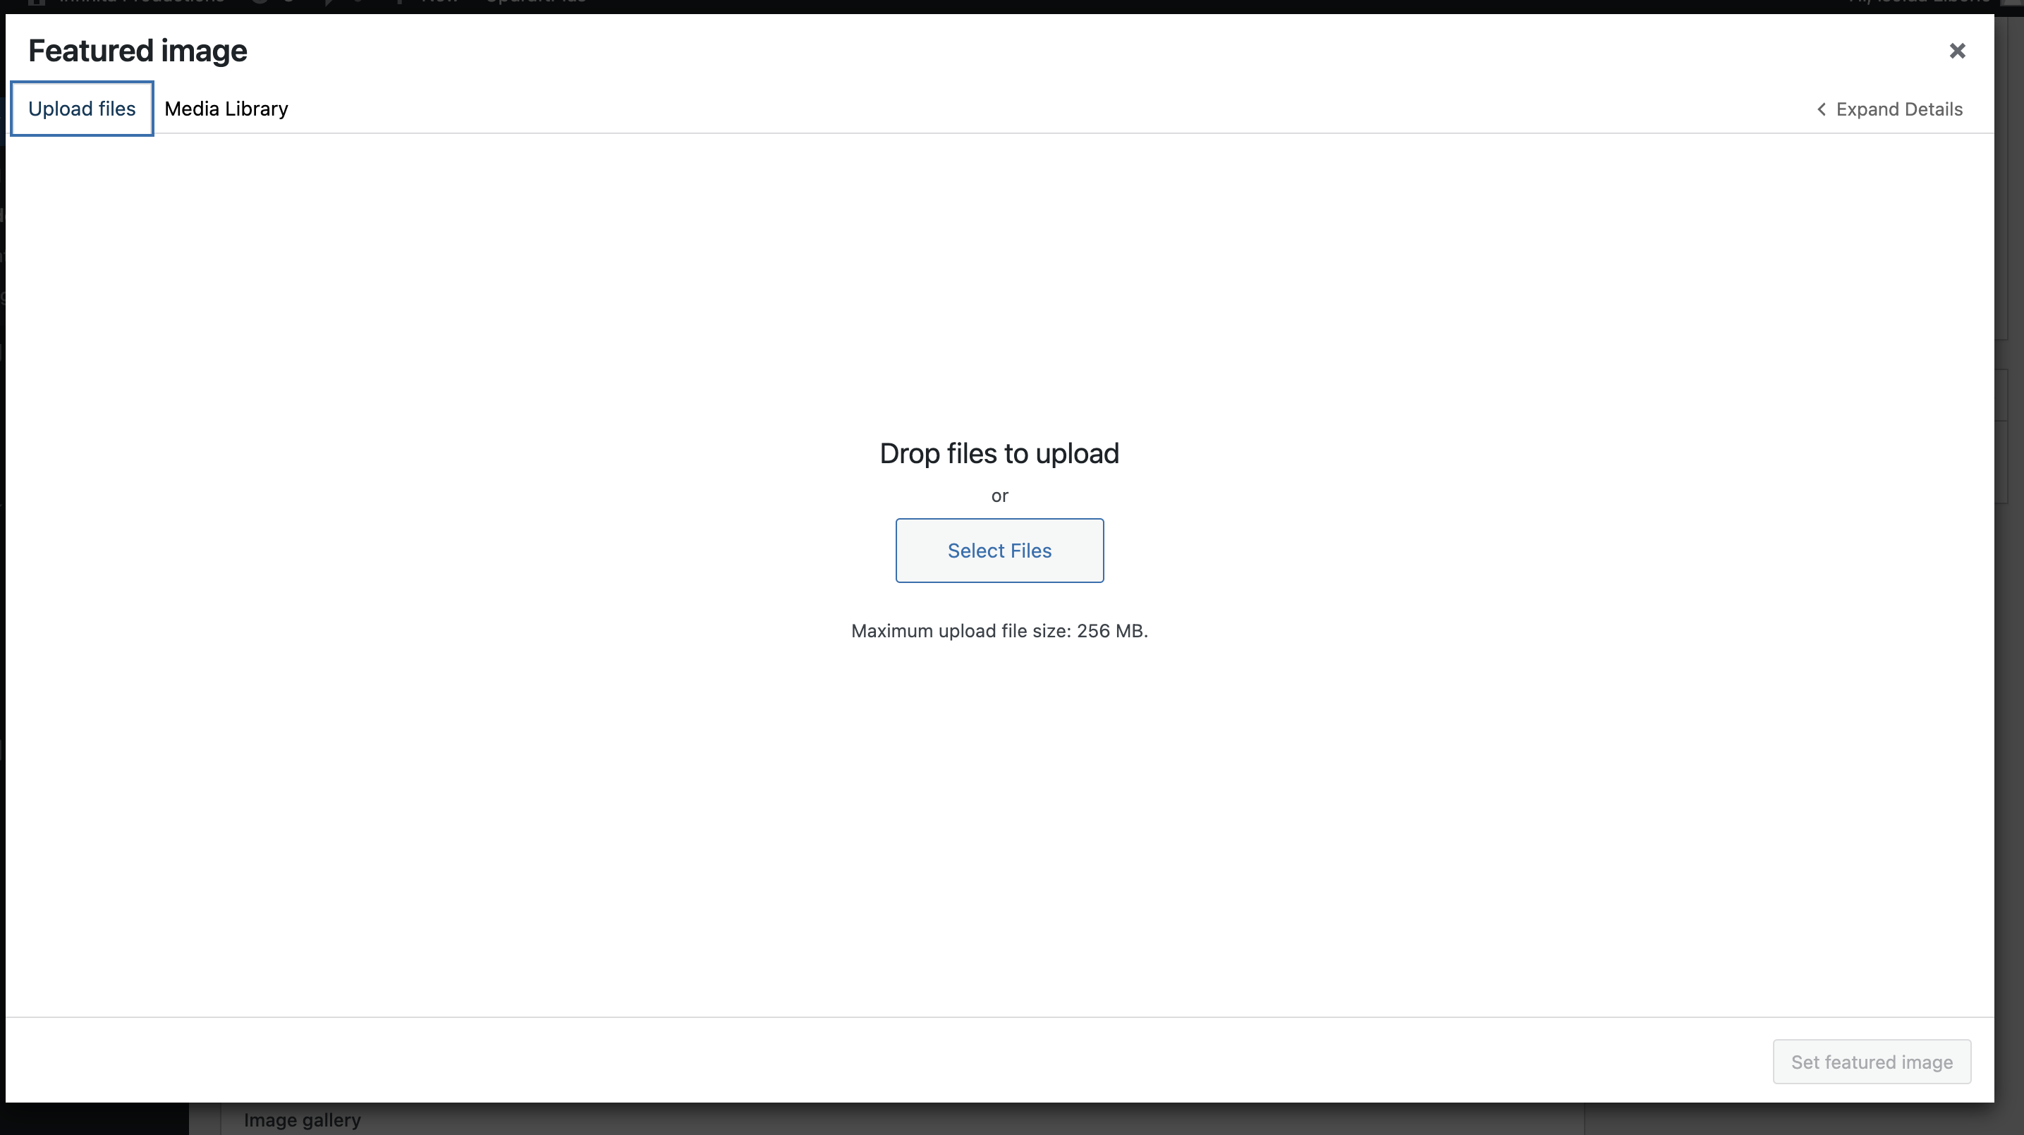

h. **Add the Inner Project Page Image/Poster**

* Go to **Featured Image > Set Featured Image**.



* Select an image in the media library if the image is already there, and set the featured image.

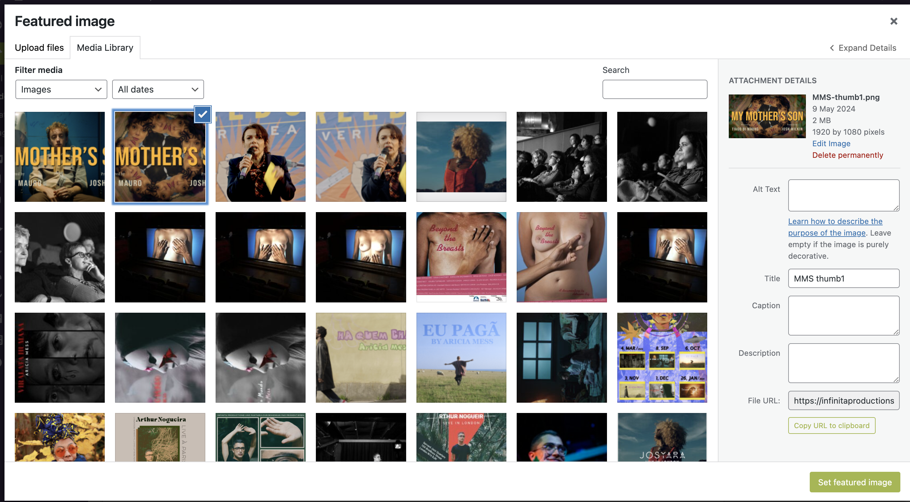

* Or go to **Upload Files**.
* Drop or select an image (maximum 256 MB).
* Set featured image.



i. **Assigning a Category to a Project**  
When assigning a category to a project, please follow these guidelines:

* Ensure that the "Uncategorised" option is not selected.
* If no category is selected, the project will default to "Uncategorised" and will not appear in any filters.



**Automatic Visualization of New Categories**  
The development is designed to automate the visualization of new categories on the website. If you create a new category and use it for new posts, it will automatically be added to the site. However, please note that the design and layout are optimized for displaying the existing 4 categories (+All).

**Example of New Category Display**  
Here you can see an example of how it is displayed when a new category is added:  
  
 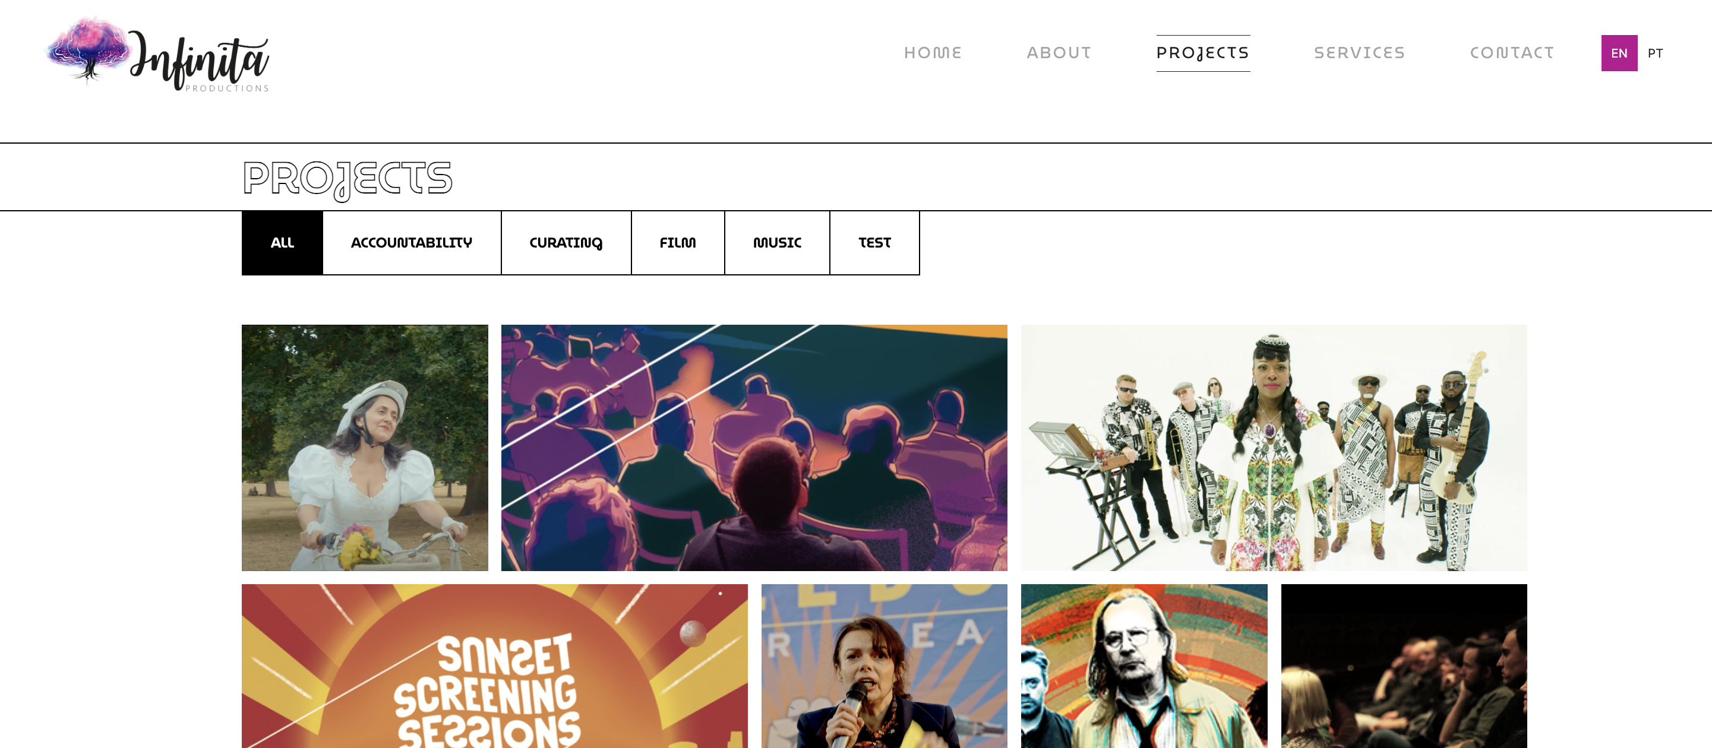

##### Adding Translation to Portuguese to the New Category

To add a new category with its translation, follow these steps:

1. Navigate to Pages > Categories.

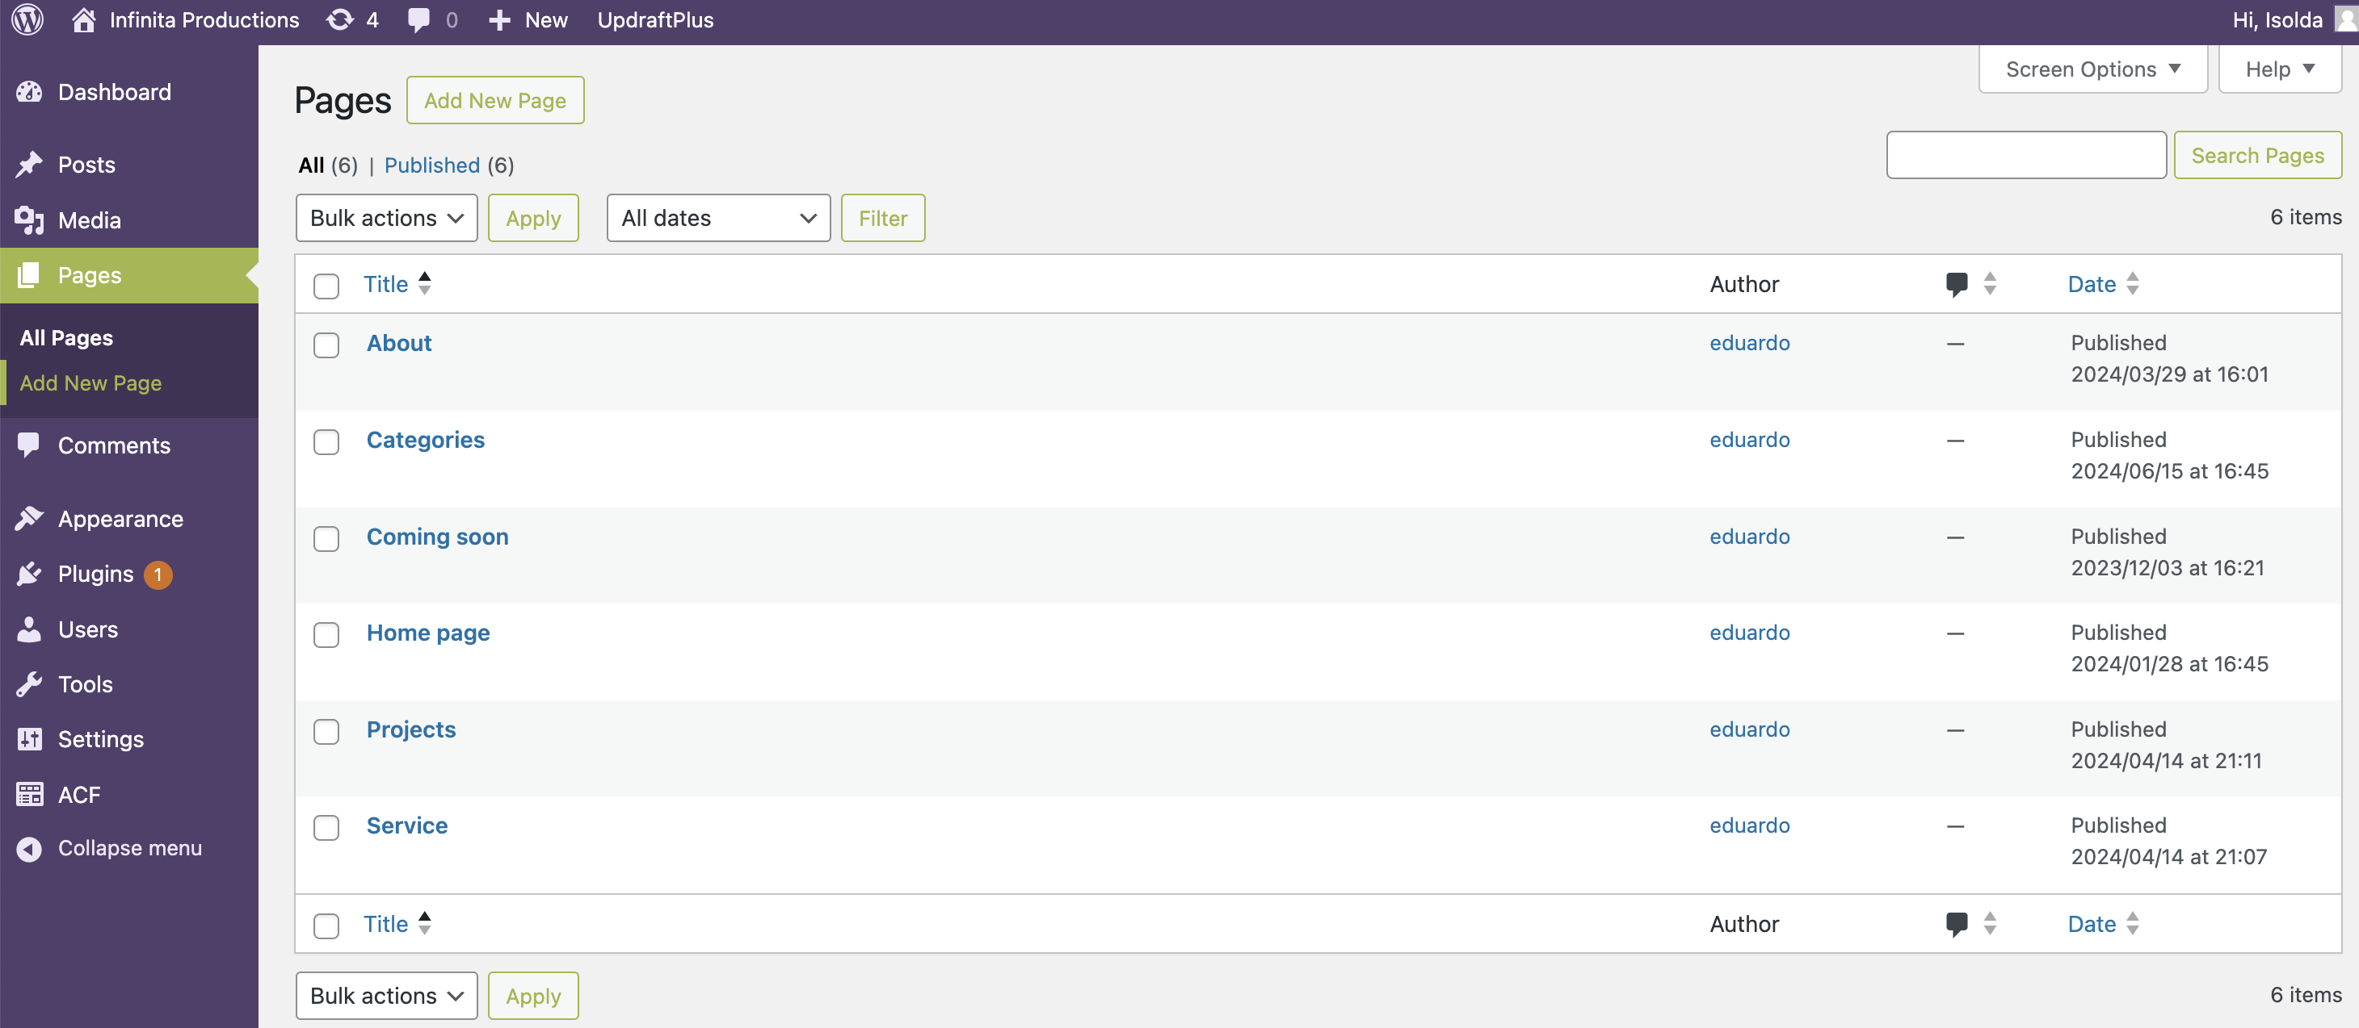

1. Add the new category in the desired language.

* Enter the translation in Portuguese, separated by a hyphen (ex: accountancy – contabilidade)
* **Example:**

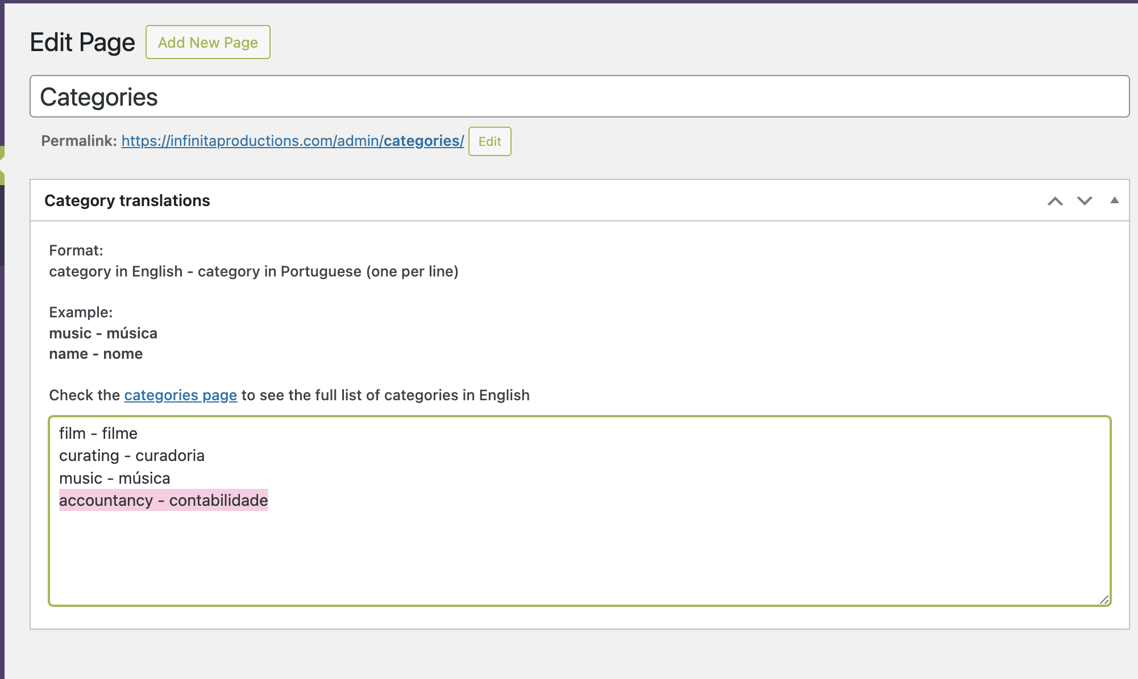

j. **Add the Project Description (and Credits)**

* Enter English in the left box and Portuguese in the right box.
* **Note:** To give a line break, keep the text on the same line and press Shift+Enter. Be aware that if you copy and paste text, sometimes you will need to delete the lines and create them again for the text to be formatted properly.

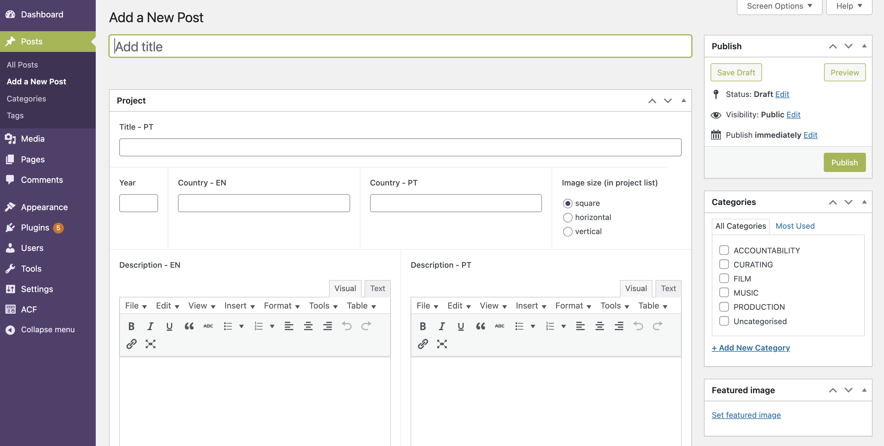

k. **Embedded Video**

* Add the link for the embedded video (YouTube or Vimeo) in the **Video URL** field.



l. **Image Gallery (on the inner project page)**

* Click on **Add Media**.



* Click **Create Gallery**.
  + Upload a new file (if the images aren’t in the media gallery already).
  + Drop the images for your gallery.
  + Create a new gallery.

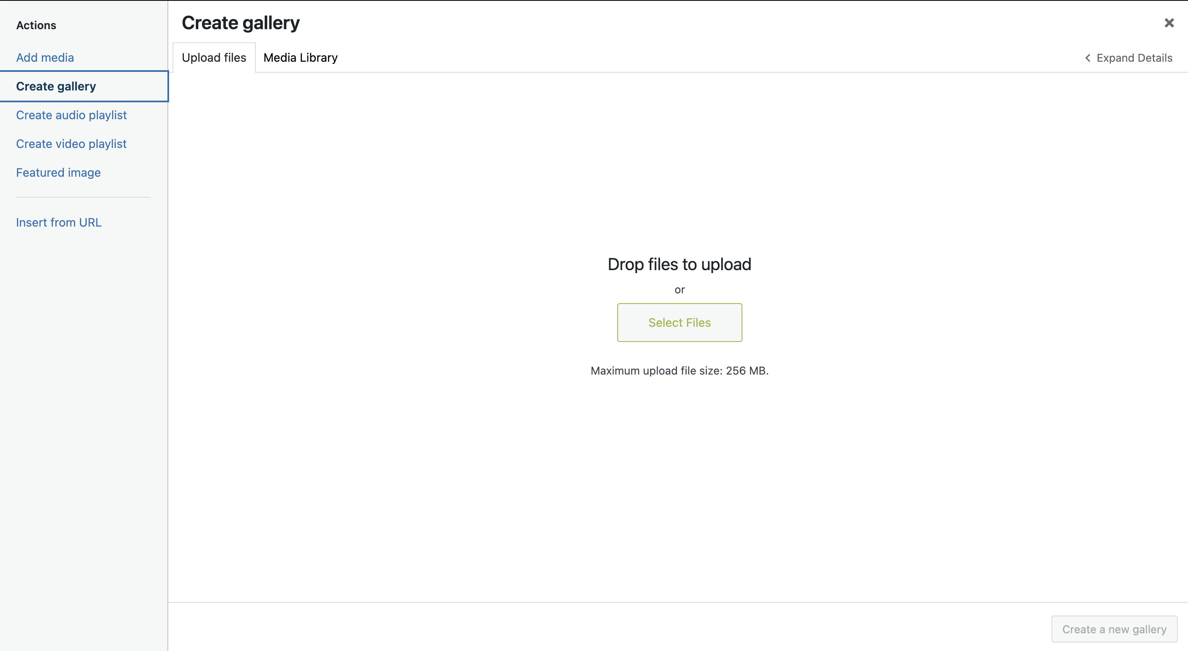

**Gallery Settings (right-hand side):**

* In **Link To**, select **Media File**.
* In **Size**, select **Large**.
* Click **Insert Gallery**.

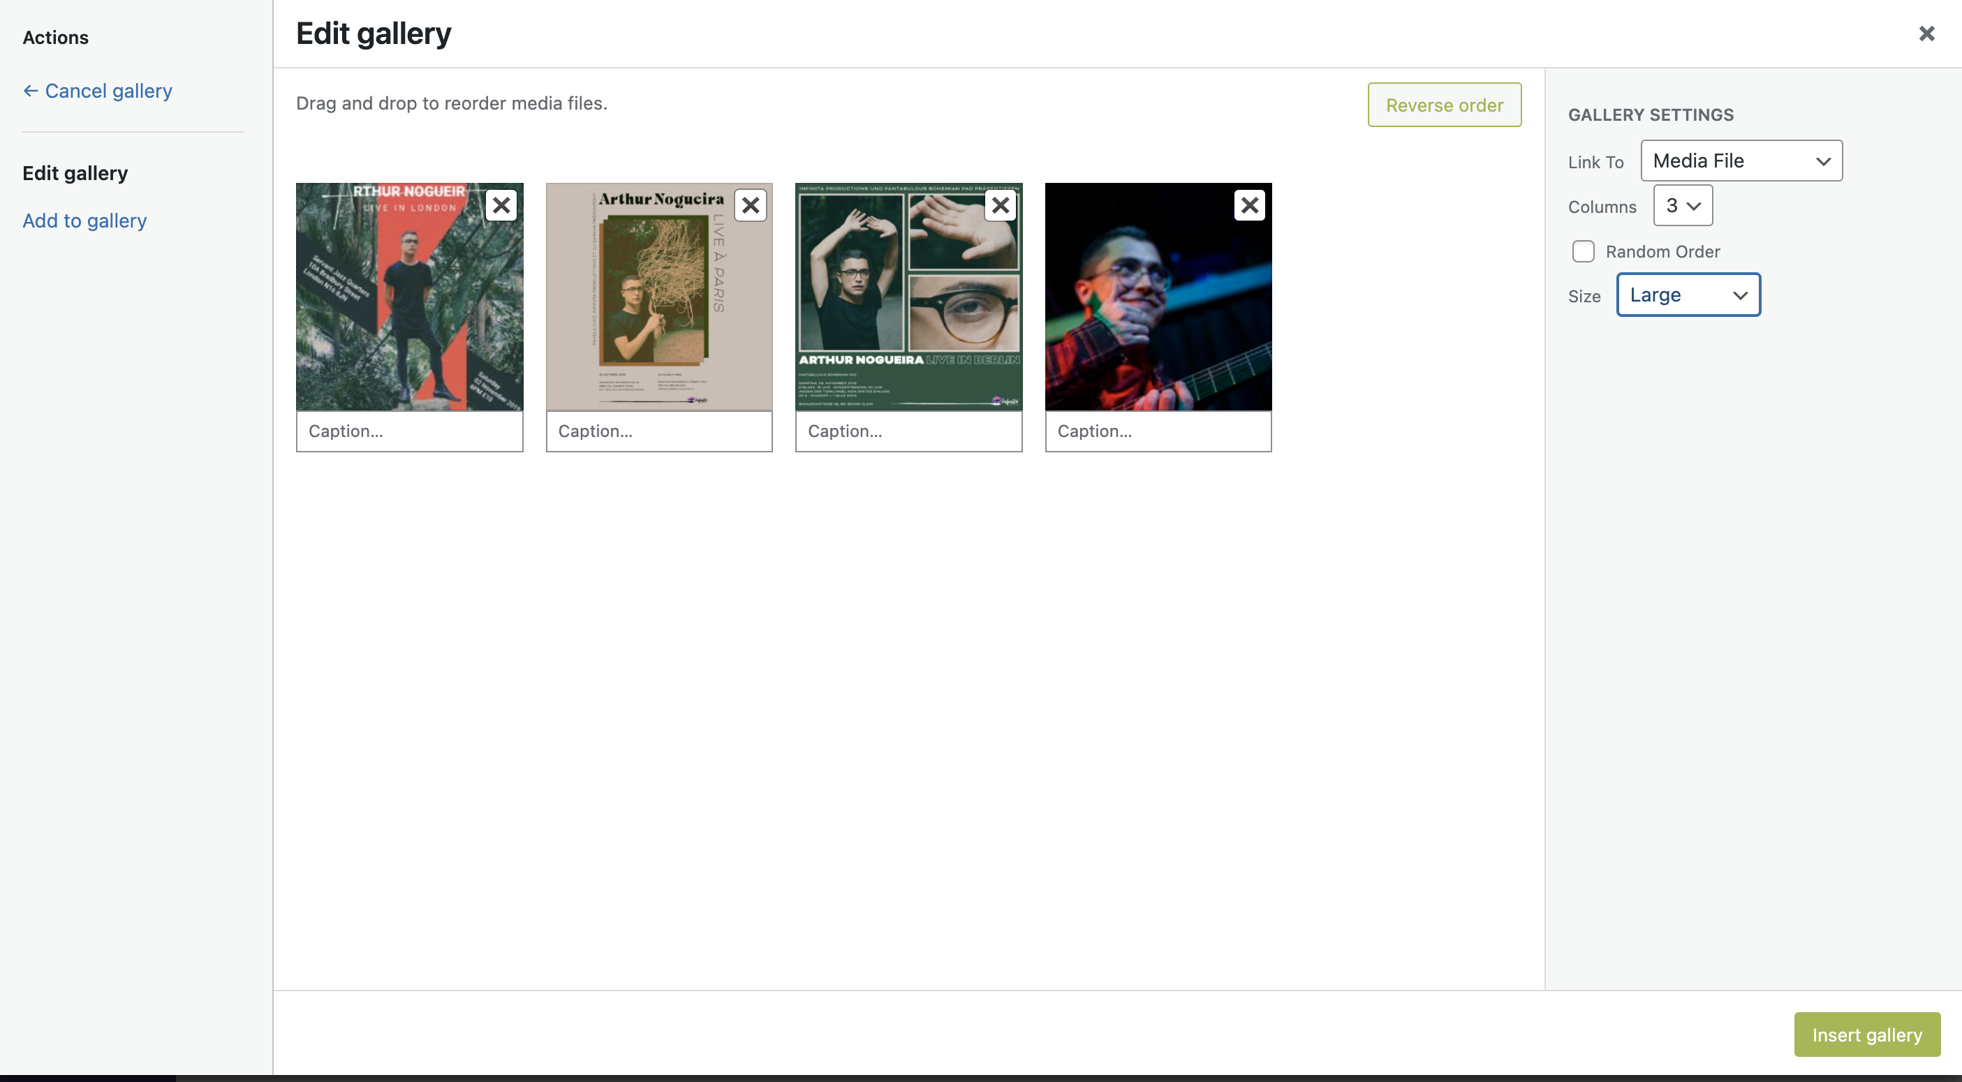

* If the image is already in the media library, select the images you want there.

